**“A Project Report On "Blood Donation Center"**

**Prepared by:**

20DCE017 – Raj Chauhan

20DCE019 – Yatharth Chauhan

20DCE024 – Deep Dhaduk

**Under the guidance of**

Prof. Dhruvi Gosai

A Report Submitted to Charotar University of Science and Technology

for Partial Fulfillment of the Requirements for the 3rd Semester

Software Group Project-I (CE244)

**SUBMITTED AT**



**DEVANG PATEL INSTITUTE OF ADVANCE TECHNOLOGY & RESEARCH**

**Department of Computer Engineering**

**CE - DEPSTAR**

**AT: CHANGA, DIST: ANAND – 388421**

**NOV 2021**



**CERTIFICATE**

This is to certify that the report entitled “Blood Donation Center” is a bonofied work carried out by **Yatharth Chauhan(20DCE019), Raj Chauhan(20DCE017)**, **Deep Dhaduk(20DCE024)** under the guidance and supervision of **Assistant Prof. Dhruvi Gosai** for the subject CE244 (For CE) **Software Group Project-I** (CE) of 3rd Semester of Bachelor of Technology in **DEPSTAR** at Faculty of Technology & Engineering – CHARUSAT, Gujarat.

To the best of my knowledge and belief, this work embodies the work of candidate himself, has duly been completed, and fulfills the requirement of the ordinance relating to the B.Tech. Degree of the University and is up to the standard in respect of content, presentation and language for being referred to the examiner.

|  |  |
| --- | --- |
| Prof. Dhruvi Gosai  Computer Engineering (CE)  DEPSTAR, Changa, Gujarat. |  |
| Dr. Amit Ganatra  Principal, DEPSTAR  Dean, FTE  CHARUSAT, Changa, Gujarat. | |

**Devang Patel Institute of Advance Technology And Research At: Changa, Ta. Petlad, Dist. Anand, PIN: 388 421. Gujarat**

**ACKNOWLEDGEMENT**

We have great pleasure in acknowledgement the help from all those who favored me in having shape to the present project. The development of this project has given me wide opportunity to think, implement and interact with various aspects of management skills as well as the new emerging technologies. We take the responsibility to express our sincere and deep sense of gratitude to our head of department **Dr. Amit Ganatra.** Our facility members and all our friends. We pay our thanks to **Prof. Dhruvi Gosai** for providing a great support to us. They guided our project team efficient and good working.

We like to pay our wish and love to our all supporting friends who made their best efforts to help us. Words defeat us in expressing thanks to our family members for providing moral support and encouragement during the tenure of the project.

We hope and wish to be blessed with the blessing and encouragement from all of the above in our future to accomplish all our endeavors.

Thanks,

20DCE017 – Raj Chauhan

20DCE019 – Yatharth Chauhan

20DCE024 – Deep Dhaduk

**ABSTRACT**

This project is aimed to developing an online Blood Donation Center Website. “Blood” one of the most important necessity of our life. The numbers of blood donor is very less when compared with other countries.

In our project we propose a new and efficient way to overcome such outline. Patient can search the blood which is he/she want and seach the city. Such as just touch the button donate will be ask to enter an individual's details like name, phone number, age, date of birth, email blood group etc. Once the app user enter the blood group and select city which he/she needed it will show blood donors detail. Once the donor donate the blood it will automatically remove the donor detail for next three months. Through this application any person who is interested in donating the blood can register himself in the same way if any organization wants to register itself with this site that can also register. "Moreover if any general consumer wants to blood online he/she can also take the help of this site. Admin is the mainauthority who can do addition, deletion, and modification if required. The project has been planned to be having the view of distributed architecture, with centralized storage of the database.

|  |  |
| --- | --- |
| Project | **Software Group Project - 1** |
| Project Name | **BLOOD DONATION CENTER** |
| Semester | **3rd Semester** |
| Submitted to | **CHAROTAR University** |
| Under the supervision of | **Prof. Dhruvi Gosai** |
| Team Members | **20DCE017 – Raj Chauhan**  **20DCE019 – Yatharth Chauhan**  **20DCE024 – Deep Dhaduk** |

**DOCUMANTATION INFORMATION**

Acknowledgement………………………………………..i

Abstract………………………………………………….ii

Documentation Information…………………………….iii

**TABLE OF CONTENTS**

1. **INTRODUCTION........................................................................1**
   1. Purpose..........................................................................1
   2. Intended audience and reading suggestions…………..1
   3. Scope.............................................................................1
   4. Tools and Technology...................................................1
   5. Definitions…………………………………………….1
   6. Problem definition of existing system………………...1
   7. References.....................................................................1
   8. Overview.......................................................................1
2. **PROJECT MANAGEMENT.......................................................2**
   1. Gantt Chart…………………………………………………..2
3. **SOFTWARE SYSTEM ATTRIBUTES…………………...….............................................3**
   1. Usability.................................................................................3
   2. Maintainability…………………………………….………..3
   3. Security………………………………...……………………3
   4. Reliability………………..………………………………….3
   5. Perfomance………………………………….……………...3

.

1. **SYSTEM REQUIREMENTS STUDY……………………………4**
   1. User Characteristics……………………………………..…4
   2. Hardware Specifications…………………………………...4
   3. Software Specifications…………………………………....4
   4. Assumptions and dependencies…………………………....4
2. **SYSTEM ANALYSIS…………………………………………..5**
   1. What is the Problem?...........................................................5
   2. Limitations………………………………………………...5
3. **SYSTEM DIAGRAMS…………………………………………6**

.

* 1. Data Flow Diagram………………………………..…,,,6
  2. Entity - Relationship Diagram…………………….…...6

..

1. **System Design……………………………………………………...7**
   1. Screen Layout…………………………………………..7
   2. Source Code…………………………………………….7
2. **Conclusion……………………………………………...…………..8**

# **INTRODUCTION**

# The main aim of this project is to save lives of people by providing blood.

# Our project Online Blood Donation Center Website.

# This website reduces the time to a greater extent that is searching for the required blood.

# Thus this application provides the required information in less time and also helps in quicker decision making.

# The data are maintained in the database. New blood details are entered in to the project to manage blood details. Blood donor details are entered and maintained in the database.

# The Software is designed to handle the blood and Search the details when required.

# It also helps to register the details of donors, blood collection details.

# The website is designed in such a manner that it can suit the needs of all the blood requirements in the course of future.

# It will help us to find the Blood group with its most efficient time to take care of the blood and it is more easy to hand over the blood to the hospital to help people to get blood on time.

## **1.1 PURPOSE**

## The blood data are maintained in the database. New blood details are entered in to the project to manage blood details. Blood donor details are entered and maintained in the database.

* Basic purpose of the system is to Search blood that occurs during the operation as well as performing calculation and updating database as and when necessary. The system is can also provide information of donor about current state



* 1. **INTENDED AUDIENCE AND READING SUGGESTIONS**
* This project is the college level project and is implementing under the guidance of college professors.
  1. **SCOPE**



* The purpose of the online system is to create convenient and easy-to-use online system for users, trying to get or donate blood. The system is based on a relational database.
* The specification builds on the experience of users of IT technology in blood transfusion that is currently available and informs both Connecting for Health (CFH) and commercial companies producing both hardware and software.
  1. **TOOLS AND TECHNOLOGIES**
* PHP, CSS, Javascript, MYSQL, Bootstrap, Jquery, Ajax
  1. **DEFINITIONS**
* **Donor** - The person who donate the blood.
* **Accepter** - The person who accepts the blood
* **Transfusion** - An act of transfusing donated blood, blood products, or other fluid into the circulatory system of a person or animal.
  1. **REFERENCES**
* <http://www.bharatbloodbank.com>
* <http://www.lionsbloodbank.net/>
* <https://www.tutorialspoint.com/php/index.htm>
* <https://www.w3schools.com/php/php_mysql_connect.asp>
* <https://www.redcrossblood.org/donate-blood/how-to-donate/eligibility-requirements.html>
  1. **OVERVIEW**
* The main aim of this project is to save lives of people by providing blood.
* Our project Online Blood Donation Center Website.
* This website reduces the time to a greater extent that is searching for the required blood.
* This application provides the required information in less time and also helps in quicker decision making

1. **PROJECT MANAGEMENT**
   1. **Gantt Chart**

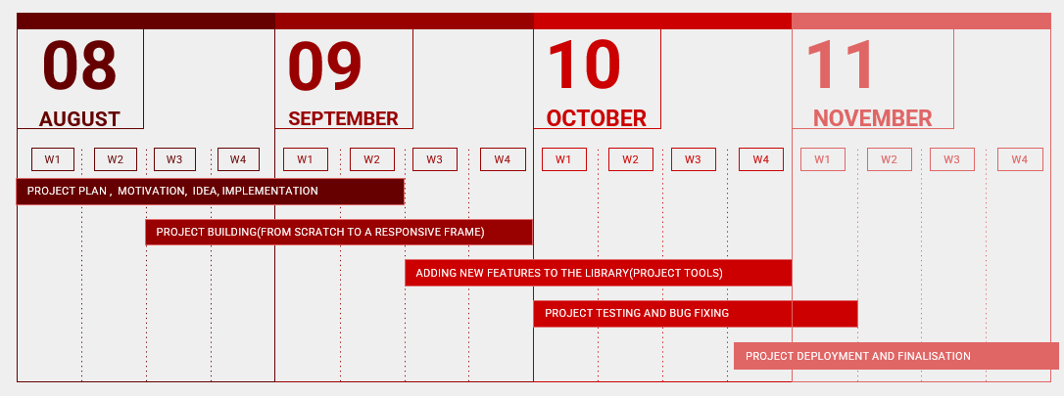

1. **SOFTWARE SYSTEM ATTRIBUTES**
   1. **USABILITY**

* The system is fully usable and does not require any pre-specified constraint to work properly.
  1. **EFFICIENCY**
* Hardware should me min. Pentium with 196 MB RAM(Fully efficient in the environments having less memory available and a reasonable speed of execution)
  1. **MAINTAINABILITY**
* In case of any change in policies and rule of the institution using the system, required changes will be made to the module written by developer.
  1. **SECURITY**
* Only the super user can enter the system to use it
  1. **RELIABILITY**
* System gives accurate result without any errors
  1. **PERFORMANCE**
* System itself is quiet fast

1. **SYSTEM REQUIREMENTS STUDY**

* 1. **USER CHARACTERISTICS**
* The system requires user to be familiar with the basic operations of computer

* 1. **HARDWARE SPECIFICATIONS**
* Processor : 1.2 Ghz or More
* RAM: 1 Gb or More
* HardDisk: 80 Gb or More
  1. **SOFTWARE SPECIFICATIONS**
* Operating System: Windows XP, 7, 8, 10
* Web Browser: Explorer, Firefox, Google Chrome
* Language Used: PHP, CSS, Javascript, MYSQL, Bootstrap, Jquery, Ajax
  1. **ASSUMPTIONS AND DEPENDENCIES.**
* Project will work for a long time and user will adopt it.
* Project will work with very less maintenance requirement.
* The database update made by the system will always leave the system in consistent state.
* There may be some small problems, which will not affect the system performance, and these will be removed easily.
* Login Process
* This system interface is used to give access to the user for the system, and mean while maintaining the security of the system.

1. **SYSTEM ANALYSIS**
   1. **Problem Definition of Existing System**
      * Entering the details about the blood groups, members, name, date of birth etc. And tracking the database is complicated when the details are maintained. This makes the maintenance of schedule erroneous.
   2. **WHAT IS THE PROBLEM?**

* The major problem in Blood Donation systems was that, they don’t follow the actual needs of users.
* Traditional blood donation systems were developed by 1 or 2 perspective.
* There was shortage and sometimes unavailability of rare blood groups due to less modules i.e. patient and donors.
* In this way we realize that the new system is required and will certainly improve the performance of the exiting system over the exiting paper based system.

1. Design the system to develop the alternative computer based system
2. To understand the user characteristic
3. Design a system for a particular types of user
   1. **LIMITATIONS**

* There is no communication between donor and patient.
* It lacks of data security.
* Patient can’t get any message or email for blood.

1. **SYSTEM DIAGRAMS**

* **DATA FLOW DIAGRAM**
* D.F.D - 1

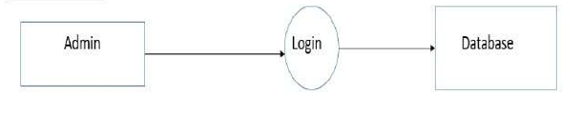

* D.F.D – 2

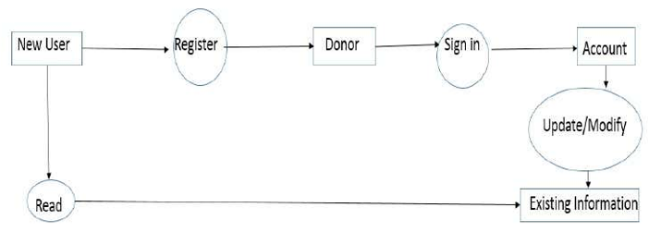

* **ENTITY – RELATIONSHIP DIAGRAM**
* D.F.D – 3

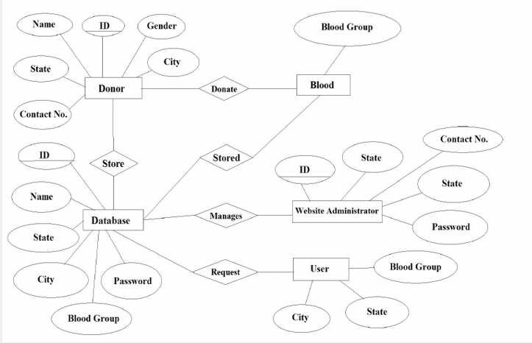

1. **SYSTEM DESIGN**

* **HOME PAGE**

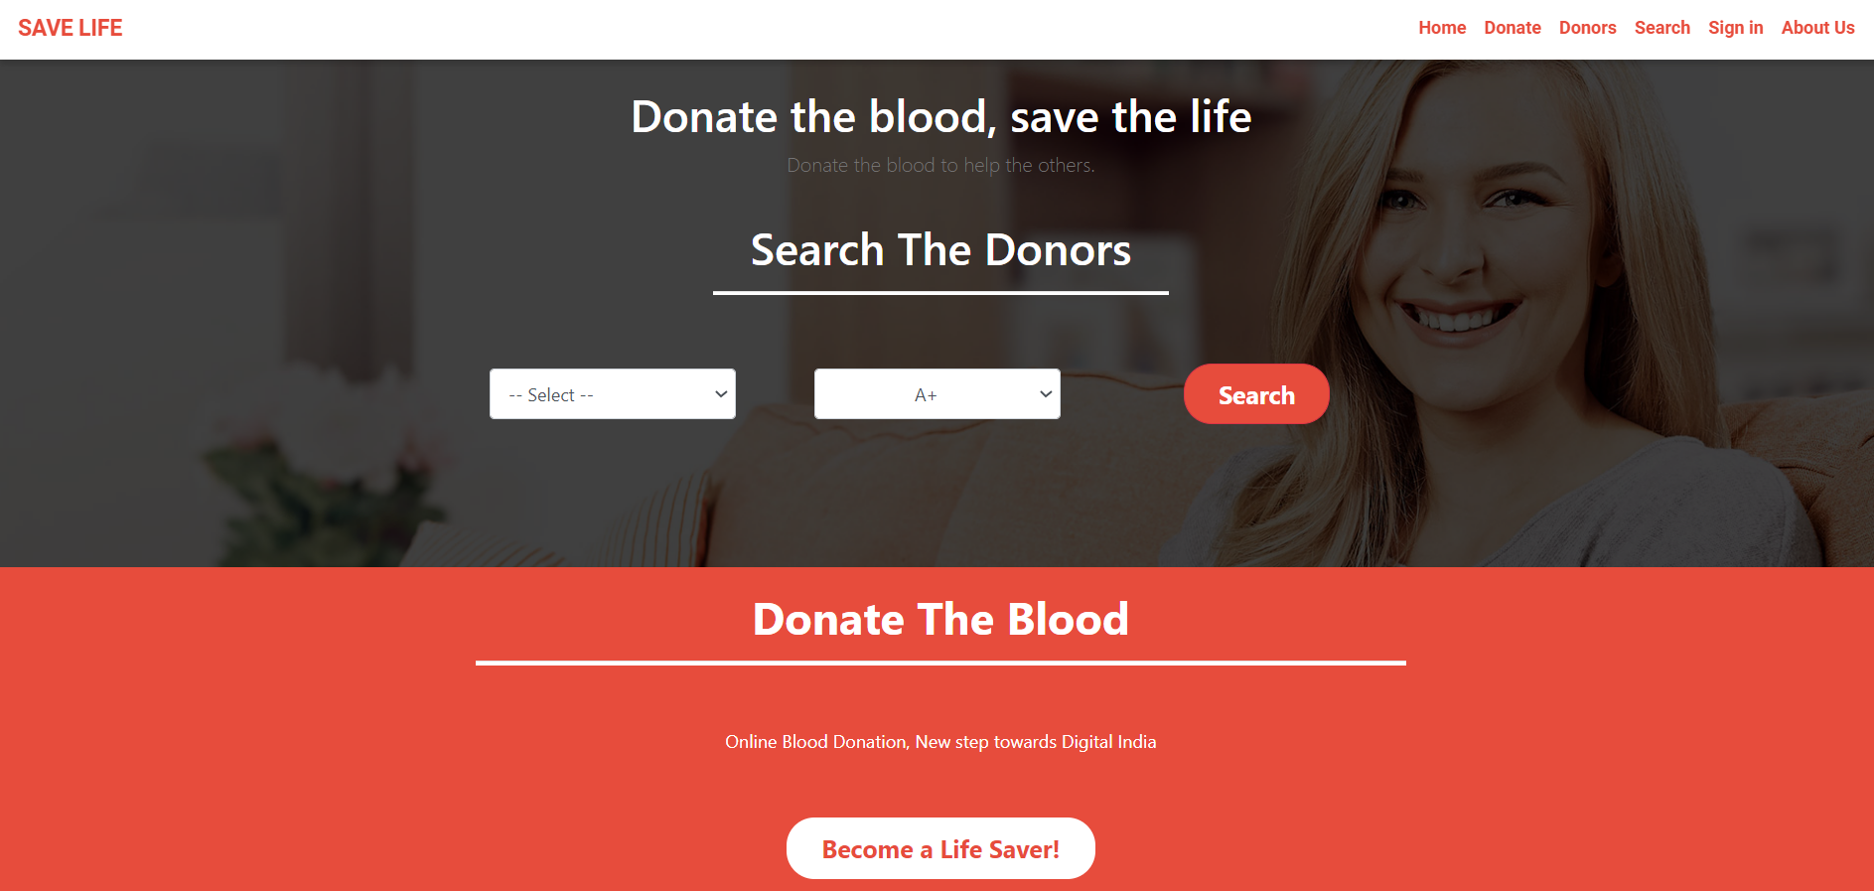

* **SEARCH PAGE**

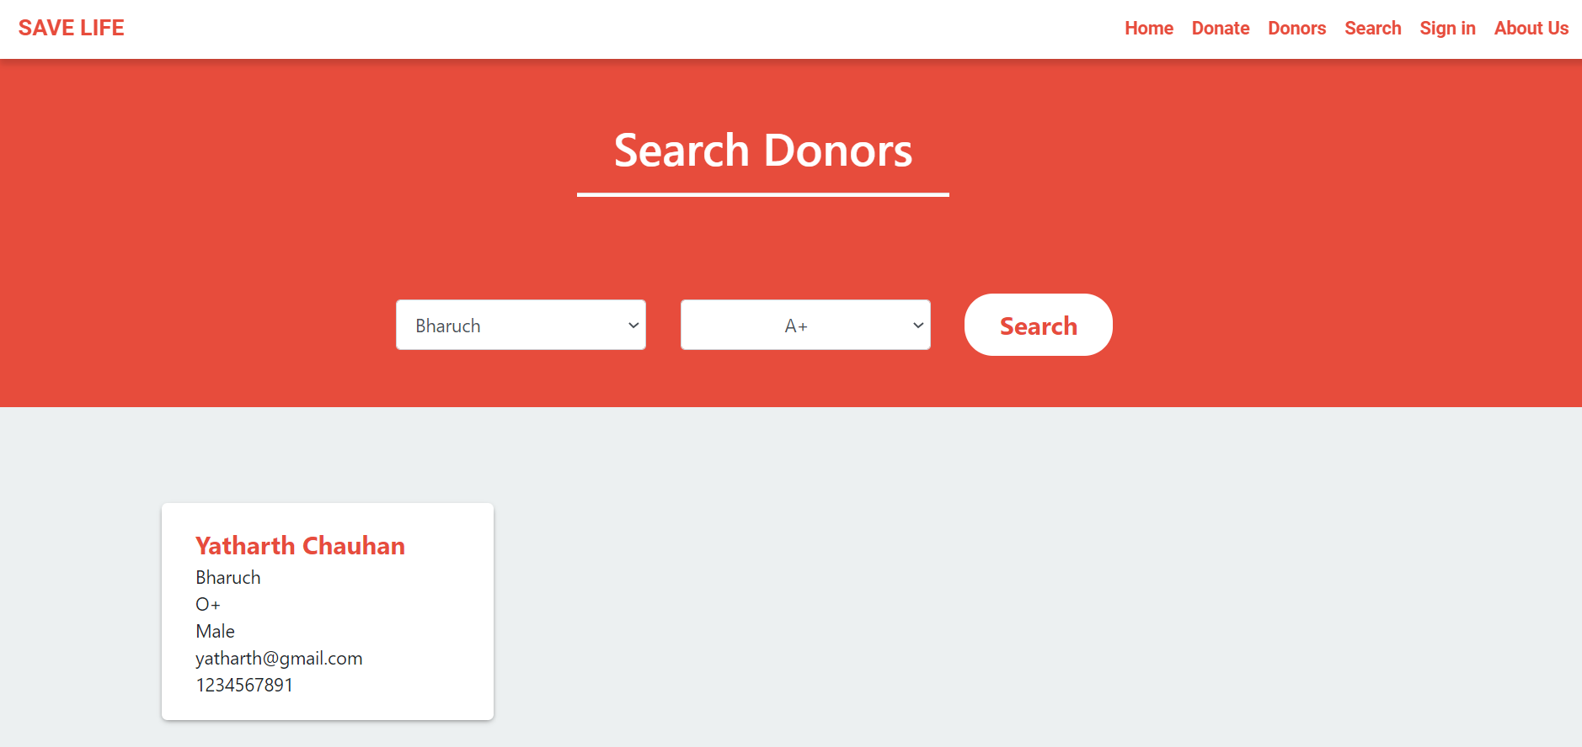

* **SIGN UP PAGE**

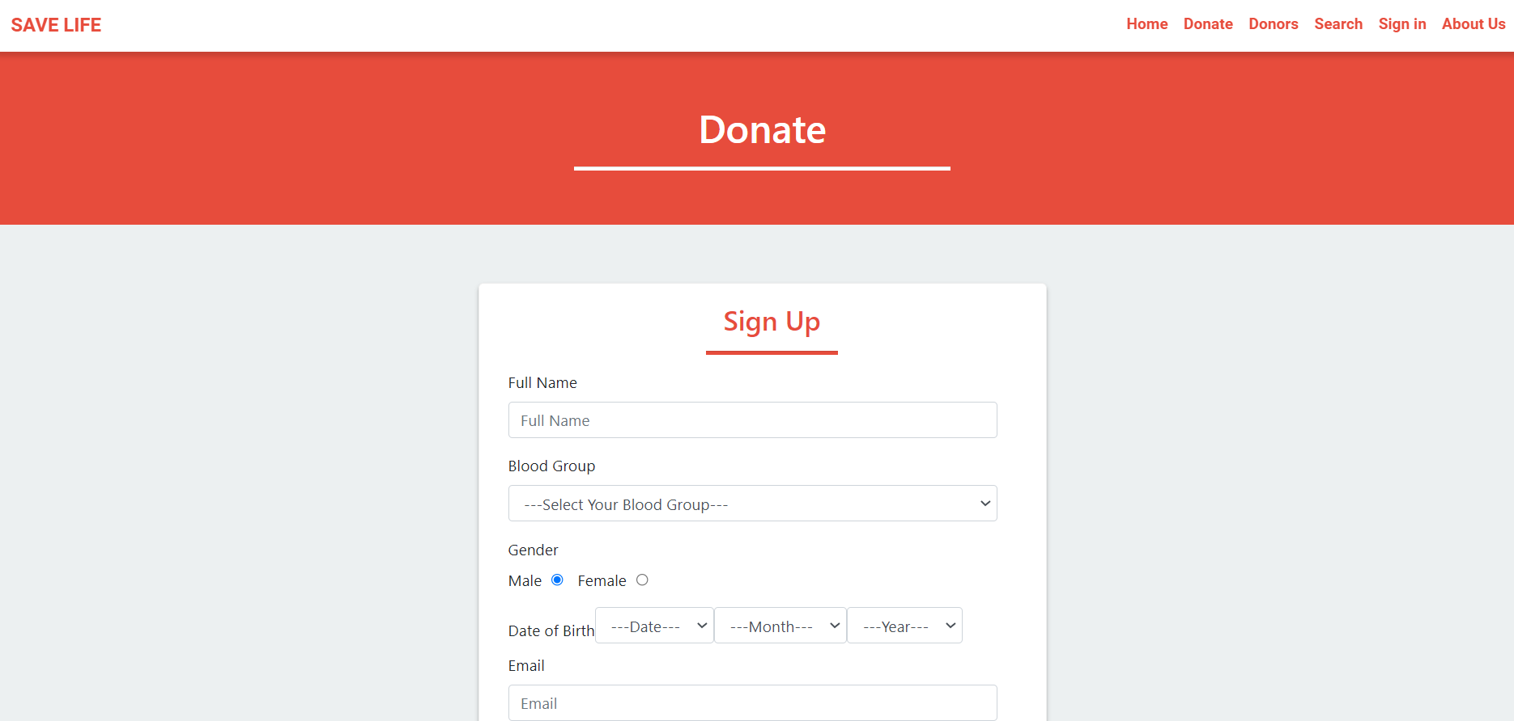

* **SIGN IN PAGE**

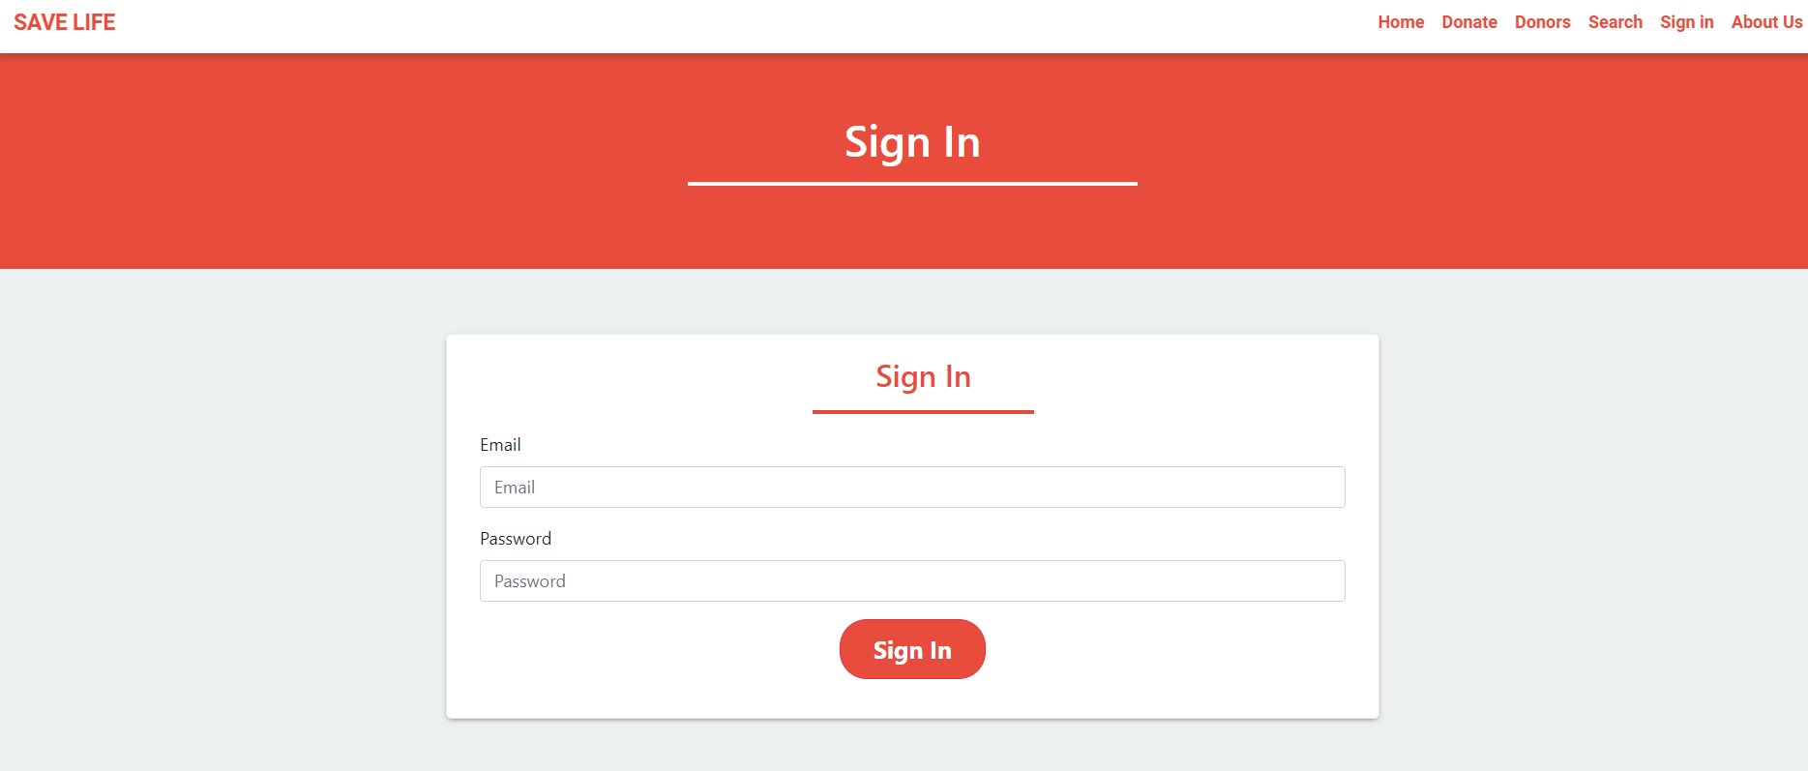

* **AFTER SIGN IN (NOT DONATED BLOOD)**

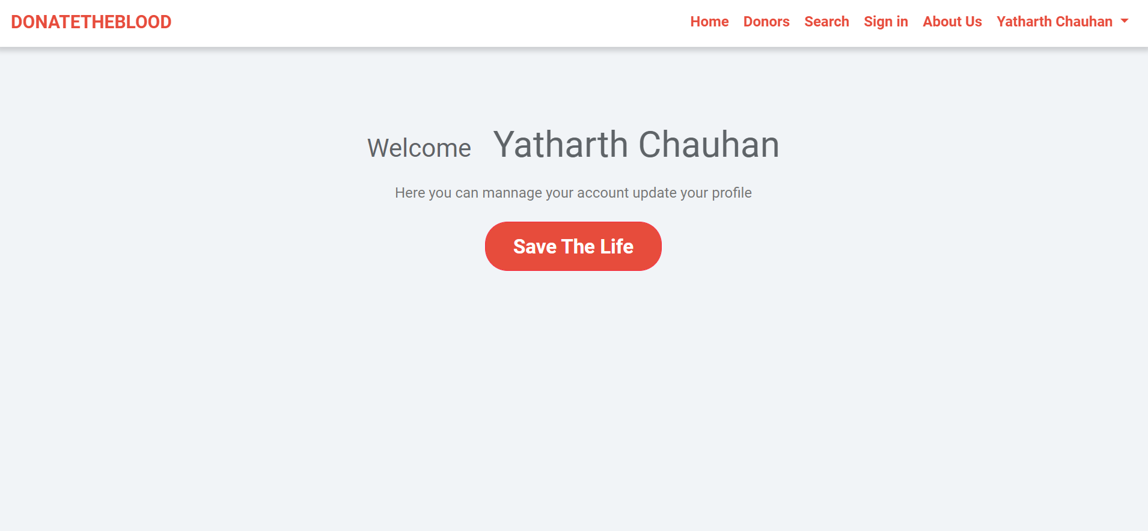

* **AFTER SIGN IN CLICK ON SAVE LIFE (DONATED BLOOD)**

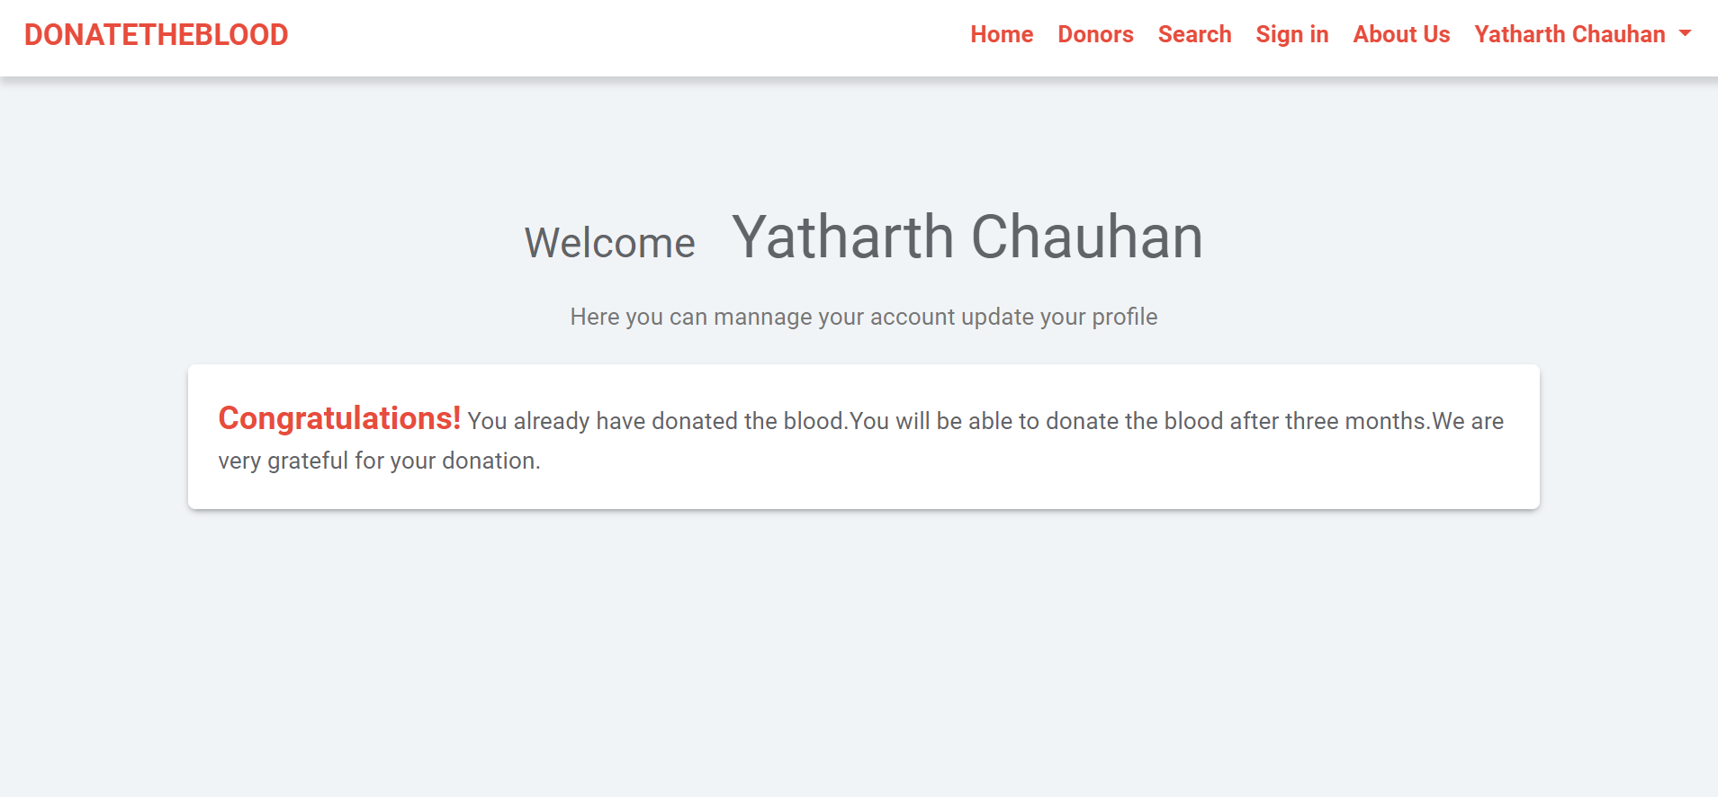

* **DASHBOARD**

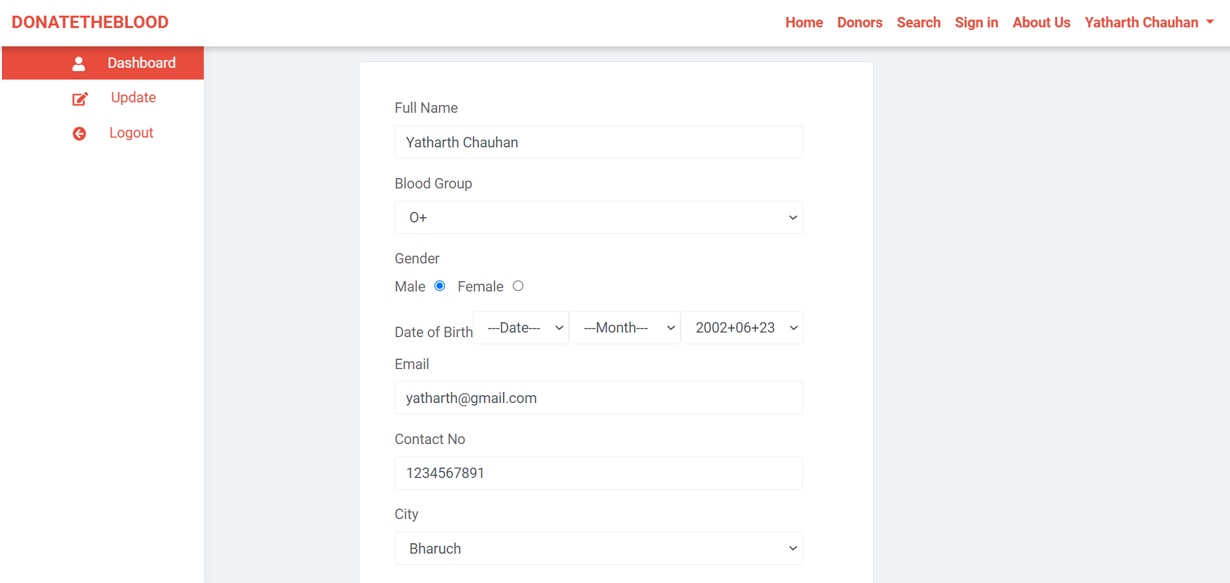

* **DONORS DETAILS PAGE**

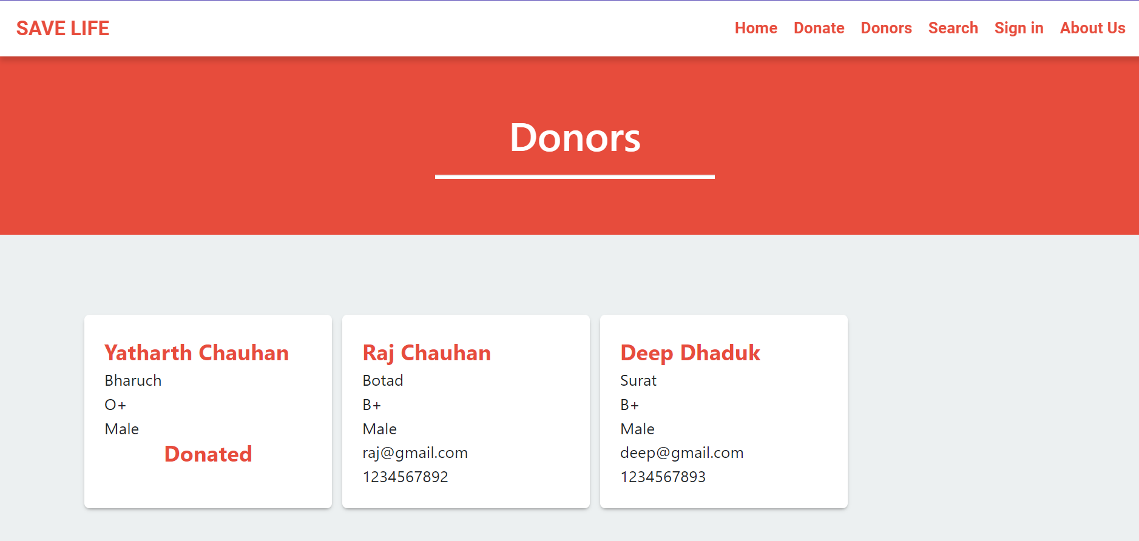

* **ABOUT US PAGE**

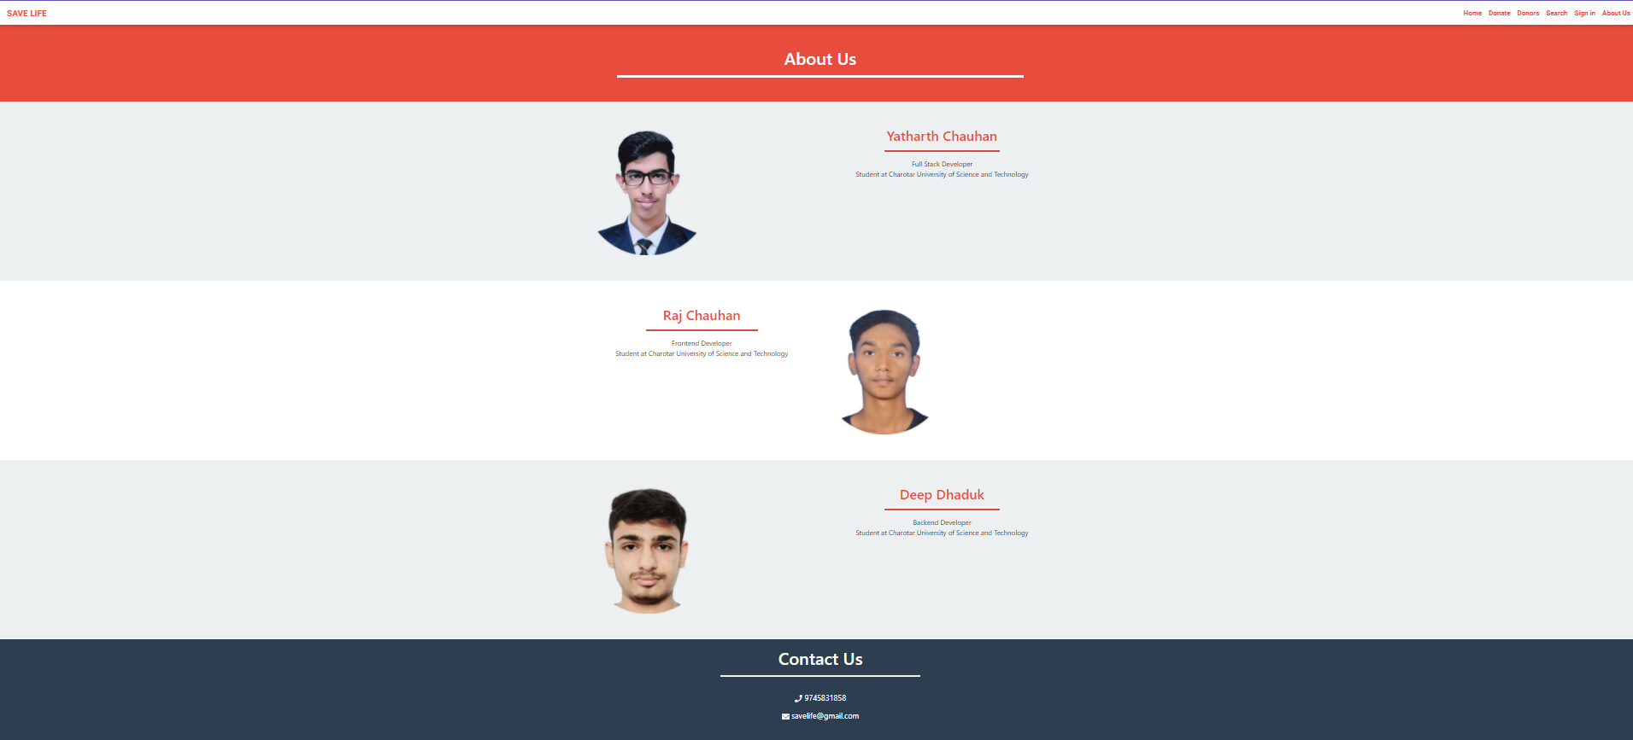

**7.2 Source Code (Github Link)**

* <https://github.com/YatharthChauhan2362/Projects/tree/main/Savelife>

1. **CONCLUSION**

* This report presents The Blood Donation related issues.
* The objectives of project is implemented by implmenting the different plans such as time estimated through Gantt chart, work background, flowchart etc...
* online blood donation system make work easy, and ensures fast retrieval of data when needed.